Template 1:

23-RD INTERNATIONAL EXHIBITION OF WELDING MATERIALS, EQUIPMENT AND TECHNOLOGIES
EXHIBITOR | 8–11 October 2024 • Hall 4, Pavilion 1, Crocus Expo, Moscow  We invite you to visit our stand № ____!  Get your e-ticket with our promo code: _____

Template 2:

Best regards,
John Doe
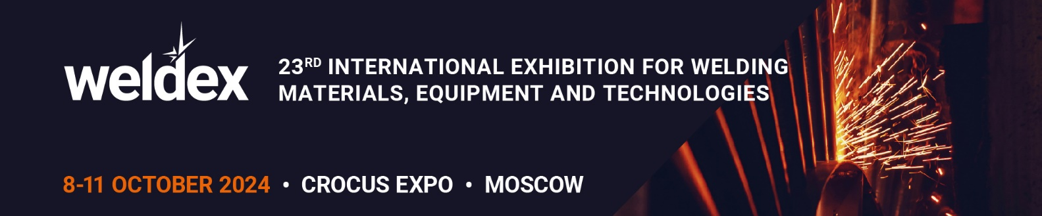
8–11 October 2024 • Hall 4, Pavilion 1, Crocus Expo, Moscow
We invite you to visit our stand № ____!
Get your e-ticket with our promo code_____________

Template 3:

Best regards,
John Doe
We invite you to visit our stand № ____!
Get your e-ticket with our promo code_____________

